**Test Case** **0038**

**System:** VirtuCardsClient

**Description:** Test to ensure that a client can select a new Avatar

**Severity:** 3

**Instructions**

**Test 1**

1. Start VirtuCardClient application
2. Click the button labeled “Sign In”
3. Enter “test@test0.com” into the text input labeled “Enter email…”
4. Enter “Password!123” into the text input labeled “Enter password…”
5. Press the button labeled “Login”
6. A window should appear saying “Login Success”
7. Press the OK button that appears on that window
8. Click the Profile icon located in the top right of the screen.
9. Click the button labeled “Edit Avatar”
10. Select another Avatar

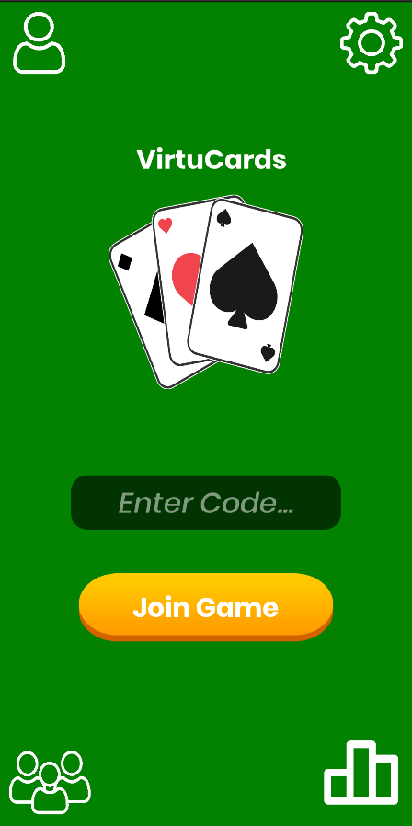**Expected Result:** The profile page should reflect the new selected Avatar

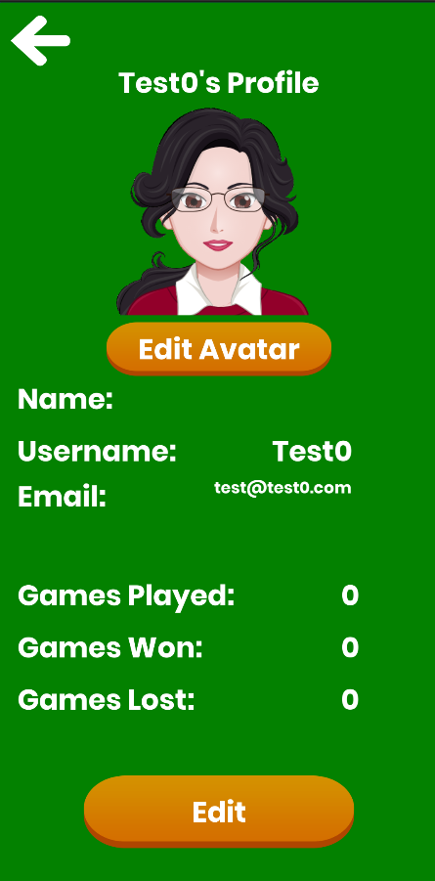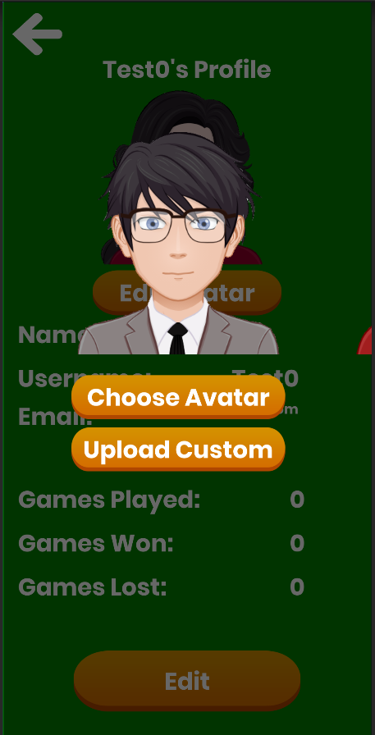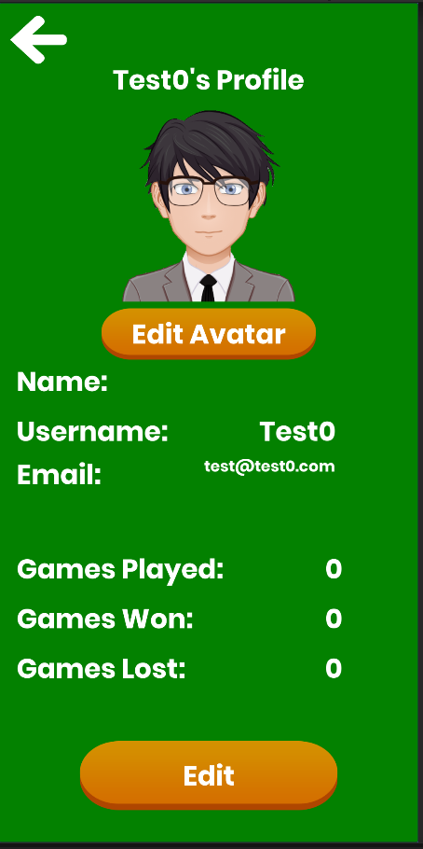

The above images outline the steps mentioned in choosing a new Avatar after logging in. The first image is the screen displayed after logging in; the second image is the profile screen viewed after clicking the profile icon; the third image is the ‘Choose Avatar’ screen seen after clicking the button of the same name; and the fourth image is the profile screen after selecting a new avatar.

**Test 2**

1. Start VirtuCardClient application
2. Click the button labeled “Google Sign In”
3. Choose a Google account you would like to sign-in with.
4. A window should appear saying “Login Success”
5. Press the OK button that appears on that window
6. Click the Profile icon located in the top right of the screen.
7. Click the button labeled “Edit Avatar”
8. Select another Avatar

**Expected Result:** The profile page should reflect the new selected Avatar

**Test 3**

1. Start VirtuCardClient application
2. Click the button labeled “Sign In”
3. Enter “test@test0.com” into the text input labeled “Enter email…”
4. Enter “Password!123” into the text input labeled “Enter password…”
5. Press the button labeled “Login”
6. A window should appear saying “Login Success”
7. Press the OK button that appears on that window
8. Click the Profile icon located in the top right of the screen.
9. Click the button labeled “Edit Avatar”
10. Select another Avatar
11. Close the application
12. Start another instance of the VirtuCardClient application
13. Repeat Steps 1-8.

**Expected Result:** The profile page should reflect the Avatar that was chosen before closing the application.

**Test 4**

1. Start VirtuCardClient application
2. Click the button labeled “Google Sign In”
3. Choose a Google account you would like to sign in with.
4. A window should appear saying “Login Success”
5. Press the OK button that appears on that window
6. Click the Profile icon located in the top right of the screen.
7. Click the button labeled “Edit Avatar”
8. Select another Avatar
9. Close the application
10. Start another instance of the VirtuCardClient application
11. Repeat Steps 1-8.

**Expected Result:** The profile page should reflect the Avatar that was chosen before closing the application.

**Test 5**

1. Start VirtuCardClient application
2. Click the button labeled “Facebook Sign In”
3. Choose a Facebook account you would like to sign in with.
4. A window should appear saying “Login Success”
5. Press the OK button that appears on that window
6. Click the Profile icon located in the top right of the screen.
7. Click the button labeled “Edit Avatar”
8. Select another Avatar

**Expected Result:** The profile page should reflect the new Avatar

1. Close the application
2. Start another instance of the VirtuCardClient application
3. Repeat Steps 1-8.

**Expected Result:** The profile page should reflect the Avatar that was chosen before closing the application.